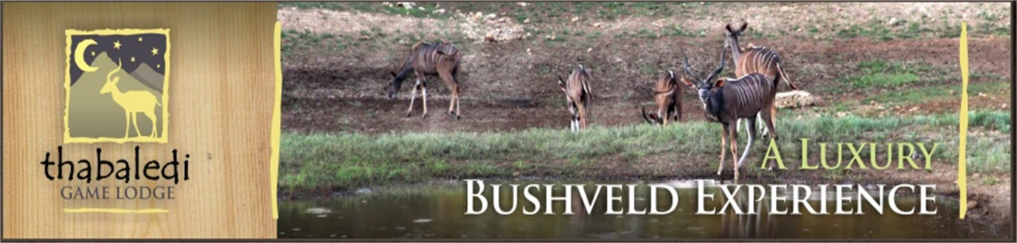
INDEMNITY AND WAIVER
(This form must be completed by all the visitors)
I, the undersigned hereby acknowledge that I am entering Thabaledi Game Lodge on my own free will and understand that Thabaledi Game Lodge is a game farm, which by its nature and function is a dangerous environment.
Further I acknowledge that I am aware that wild animals are dangerous and roam freely on the farm. I also acknowledge that neither the farm vehicles nor roads have been properly maintained due to the restricted nature of their use on the farm.
Further I accept all the risks involved in staying and/or hunting in this wild environment and fully accept responsibility for all my actions and my personal safety and that of my minor children, at all times.

WITH THIS KNOWLEDGE I AM INDEMNIFYING AND HOLD HARMLESS

THABALEDI GAME LODGE, ITS OWNERS AND ALL ITS STAFF, AGAINST ALL CLAIMS THAT MAY ARISE IN RESPECT OF ANY INJURIES, DEATH, DAMAGE, LOSS, COSTS AND EXPENSES INCURRED OR SUSTAINED DURING ANY VISIT TO THE FARM. THIS INCLUDES ANY CONSEQUENTIAL INJURIES, LOSSES OR DAMAGE REGARDLESS WHETHER SUCH INJURIES LOSS OR DAMAGE IS CAUSED BY ANY NEGLIGENCE OR NOT ON THE PART OF THE MANAGEMENT OF THABALEDI GAME LODGE OR THEIR EMPLOYEES OR AGENTS.
This waiver and indemnity is binding on me, my executors, my dependants, guests and invitees.
This waiver and indemnity shall remain effective for the full period that I/We are on the farm and for 30 days thereafter.

SIGNATURE: _____________________________________ DATE: ________________

NAME: _____________________________________ ______________

CONTACT DETAILS: CELL NUMBER: ______________________________________________________

EMAIL ADRESS: _____________________________________________________

FAILURE TO COMPLETE THIS DOCUMENT CORRECTLY AND TRUTHFULLY ABSOLVES THE COMPANY, MANAGEMENT AND/OR STAFF FROM ANY CLAIM WHATSOEVER AND AUTHORISES THEM TO ENFORCE THE RIGHT OF ADMISSION RESERVED.

